Solutions

3(a) The term Brownian motion refers to either
- The physical phenomenon where minute particles, immersed in a fluid or floating on its surface, move about randomly; or
- The mathematical models used to describe such random movements.
A description of a colloidal suspension in terms of Brownian motion is most appropriate at low densities because the positions of the colloidal particles are practically uncorrelated and the chance of finding a particle in any particular vicinity is almost independent of the presence of all the other particles.
(b)
(i) Suppose that the particles are subjected to an external force F in the x direction, e.g. gravity. In thermal equilibrium the Maxwell-Boltzmann distribution is valid, i.e. the particle density n(x) is given by
where we assumed a constant force F in the last equation. In the case of gravity
F = m_{B}g with m_{B} the buoyant mass. n(x) results from the balance between the motion of the particles due to the external force setting up a concentration gradient, and the resultant diffusion given by Fick's law.In the case of gravity, this leads to a sedimentation equilibrium.

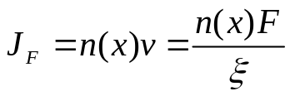Now, the velocity of a particle under an applied force F in a viscous fluid can be written as v =F/ξ which defines the friction coefficient ξ. Hence

The Diffusive flux, J_{Di} is given by Fick's Law

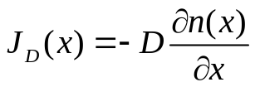

Equating the two fluxes J_{F} = J_{D} we get

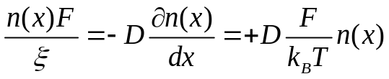

The second equation here is obtained by differentiating the Maxwell-Boltzmann distribution. This gives the relation between the diffusion and friction coefficients, which is the Stokes-Einstein relation
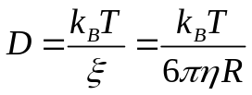where we have used Stokes law 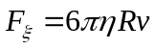(with η the viscosity) for the frictional force on a sphere.
Assumptions: The only requirement is that the force must be constant, thus like charged colloids in a uniform external electric field would not exhibit the same behaviour because the non uniform particle density would result in a non uniform effective E-field.

C(i) The distribution of particle number is : 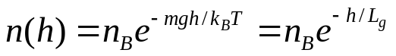 where the `gravitational length’ 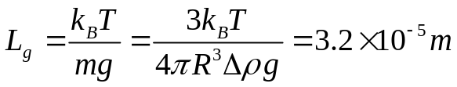

C(ii)
From the Maxwell-Boltzmann distribution:
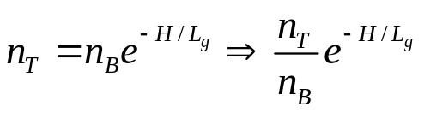

At a height of 100μm above the bottom of the container, the density has fallen to e^{-3.1} =0.045, of its value at the bottom. Note the Boltzmann distribution as used above is only valid if the particles do NOT interact with each other. Otherwise 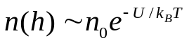 where U is the gravitational p.e. + interparticle interaction.

C (iii) In order to establish the concentration gradient, some particles initially at the top of the sample will have to settle to the bottom, Thus some estimate (probably an underestimate) of the time required is the time taken by a particle to sediment a distance H. The time t can be calculated from the sedimentation velocity. The latter is found by equating the gravitational force 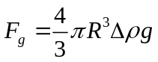 to the Frictional force 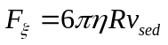

Hence
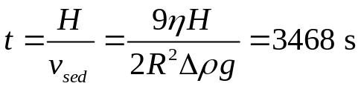

2 (a)
Many polymers are highly flexible and are coiled up in solution. In a simple model we thus describe a polymer as consisting of a large number of segments freely joined up, where all angles between segments are assumed to be equally likely.

The momomers are located at positions Rj and connected by bonds 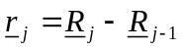 of length 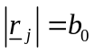.The end-to-end vector is 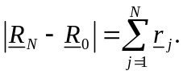 At any instant, the configuration (arrangement) of the polymer is one realisation of an N-step random walk in three dimensions. In time, the various segments undergo Brownian motion and the polymer fluctuates between all possible configurations of the random walk | 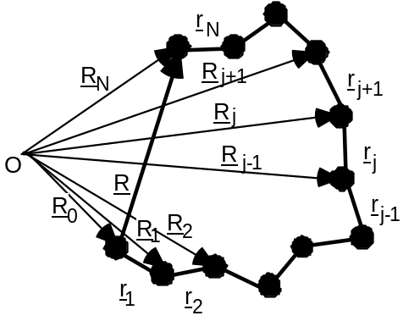
.
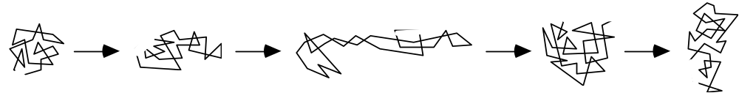

Based on the end-to-end vector R, the size and shape of the chain can thus be described probabilistically:

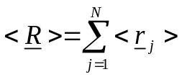
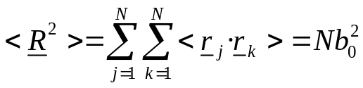
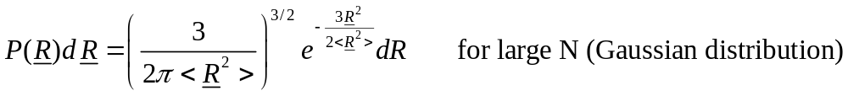
(ii) While the end-to-end distance represents a well-defined quantity for a linear chain, we need a more versatile measure of the size for more complicated architectures, such as branched or star-shaped polymers. This is provided by the mean square distance from the centre of mass RG, the so-called radius of gyration Rg, which is also a measure of the extension of a (random) chain:

(b)

In a polymer molecule the bond angles are usually restricted, which leads to a limited flexibility of the molecule. An example is a molecule such as n-butane which can exist in trans and gauche forms.

This suggests that a model should be based on fixed angles between bonds, but free rotation about the bonds. This is the freely-rotating chain:

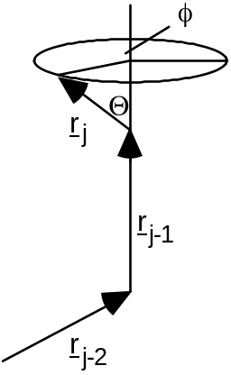

On a smaller length scale the behaviour will be dominated by the finite flexibility or 'persistence' of the chain, which is characterised by the Kuhn length b. The chain will essentially behave like a stiff rod on this length scale. On a very global length scale, it has a molar mass M and an overall size which can be characterised by the root mean square end-to-end distance <R2>1/2 or radius of gyration
<Rg2>1/2 ∝ Nν ∝ Mν, where ν = 1/2 for a freely-jointed or freely-rotating chain
Further improvements to the model can take account of the fact that two monomers cannot occupy the same space. This leads to an increase in the exponent to ν = 3/5 for an excluded volume chain (self-avoiding random walk).

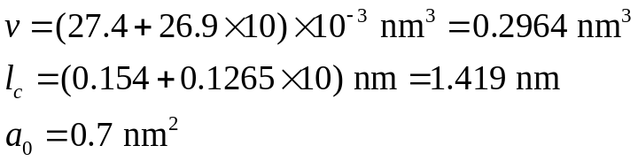(c) Using the formulae stated, we can calculate the volume of the hydophobic part and the critical chain length as

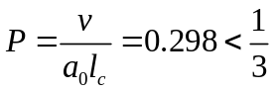
Hence the critical packing parameter is
implying spherical micelles. For spherical micelles, we have
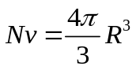 and 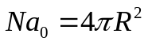

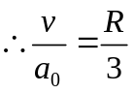. Hence average size is R=1.27 nm

Finally, since 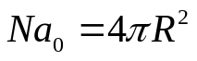, we can calculate that N=29.

